Name of Group*
Name of Contact person*
Postal Address of Contact person* | Postcode:
Telephone Number* | Home:  Work:  Mobile:
Email address*

Alternative Contact Person*
Telephone Number* | Home:  Work:  Mobile:
Email address*

What is the name of your project?

When do you expect your project to happen? | Start Date: | Finish Date:
What Electoral Ward/ Postcode will your project cover?
Please note projects should be completed by Friday 28th February 2026 with claims and supporting information submitted to Council within 10 days of project closure. This is to allow submission to The Executive Office and EVAWG and meet the end of year financial deadline.
Change Fund
Application Form
2025 - 2026

CLOSING DATE: THURSDAY 3rd APRIL @ 4.00pm

Target Age Group (Place an X in at least 1 of the boxes)

Under 18 |  | 18-30
30-60 |  | 60+

How many people will the project benefit? (Place an X in the relevant box)

0-30 |  | 31-60
61-100 |  | 100+

Target Group

Male |  | Female |  | Prefer not to say

Are you applying to any other council area for this project?

Yes |  | No |  | If Yes - Give Details

Details of any partners/collaborations

Name of Partners/ Collaborations | Organisations

Do you have safeguarding requirements in place?

Yes |  | No |  | If No, do you agree to sign up to ANDBC safeguarding policy? | Yes | No

Grant funding up to a maximum of £25,000 may be awarded to successful community groups operating within Ards and North Down Borough Council. The minimum grant awarded will be £1,000. Funding can be applied for within three tiers of support:

Tier 1: grants between £1,000 and £5,000

Tier 2: grants between £5,001 and £15,000

Tier 3: grants between £15,001 and up to £25,000

Please Tick which tier of funding you are applying for. (Organisations can only apply for one tier of funding).

Tier 1 ☐ Tier 2 ☐ Tier 3 ☐

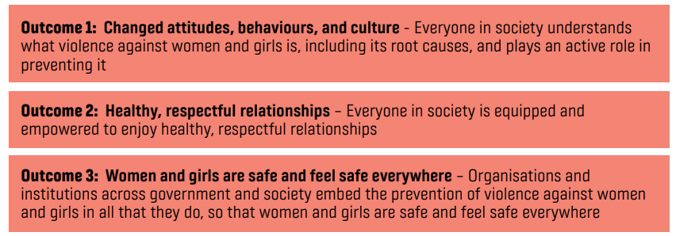
All grant applications must address Outcome 1 as a minimum requirement:

Organisation/ Group Profile
Please provide a short description of your organisation or group. Explain how the aims, objectives and activities of the organisation / group align with the aims of the Ending Violence Against Women and Girls Strategic Framework, and specifically the Prevention Outcomes 1, 2 & 3. Focus should be on Outcome 1.

(500 word limit – if you need to submit more detail please do so in an Annex)

Proposal Description for Tier 1 Funding

Insert a short description of your proposal to explain how it meets the criteria for Tier 1 funding. Awards may be for one-off events, projects, workshops or small clusters of activity aimed at awareness raising and aligned with the Prevention Outcomes 1, 2 & 3 in the Ending Violence Against Women and Girls Strategic Framework. Focus should be on Outcome 1. Please detail the impact of your proposal; for example, how many participants will you reach / workshops delivered, etc.

(500 word limit – if you need to submit more detail please do so in an Annex)

Proposal Description for Tier 2 Funding
Insert a short description of your proposal to explain how it meets the criteria for Tier 2 funding. Awards may be for planned programmes of activity, longer running initiatives, educational courses aligned with the Prevention Outcomes 1, 2 & 3 in the Ending Violence Against Women and Girls Strategic Framework. Focus should be on Outcome 1. Awards may also be for activities described in Tier 1. Please detail the impact of your proposal; for example, how many participants will you reach / workshops delivered, etc.

(1000 word limit – if you need to submit more detail please do so in an Annex)

Tier 3 applicants must complete both boxes below:

Proposal Description for Tier 3 Funding
Insert a short description of your proposal to explain how it meets the criteria for Tier 3 funding. Awards may be for planned programmes of activity, longer running initiatives, educational courses aligned with the Prevention Outcomes 1, 2 & 3 in the Ending Violence Against Women and Girls Strategic Framework. Focus should be on Outcome 1. Awards may also be for activities described in Tier 1. Please detail the impact of your proposal; for example; how many participants will you reach / workshops delivered, etc.

(1500 word limit – if you need to submit more detail please do so in an Annex)

Additional information for Tier 3 Funding

Please demonstrate how your proposal contains aspects of mentoring or collaboration.

By ‘mentoring’ we mean where a more experienced organisation with better developed capacity will assist another less experienced organisation or organisations in developing the skills and knowledge to perform more effectively. This may include sharing resources and networks. This is with a view to building the capacity of the mentored organisation.

Collaboration is defined as working with organisation(s) of a similar level/capacity and can include working with both voluntary and statutory organisations.

(1,000 word limit – if you need to submit more detail please do so in an Annex)

Budget Request
Please provide a breakdown of all proposed expenditure in the Total Project Costs table. Break the costs down under suitable budget headings which adequately describe the proposed expenditure. Please specify the VAT status of your organisation.

Total Project Costs
Budget Heading | Requested
Total
Total Requested from EVAWG Change Fund
Vat Registered | Yes | No

Value for Money
Please demonstrate how your proposal demonstrates value for money. Please reference how this is the minimum amount of funding required to achieve the activities within this proposal and that there are no other sources of funding available.

Have you applied for or are you currently in receipt of funding for your project from any other funders? (Please tick appropriate box)

Yes ☐ No ☐

If yes, please complete the following table:

Duplication of funding
Confirmation that there will NO duplication between this funding and funding from other sources. If you are accepting other funding that is not being used for this proposal but may be relevant, please set it out below:

Funding contributor | Amount of funding | What funding is supporting

Project Risks
Identify any potential risks to the successful delivery of your project and how you plan or reduce the potential impact of these risks.

Delivery Plan
Please include a work plan setting out the whole project approach, and experience of delivering similar programmes

Monitoring and Evaluation
You are best placed to tell us about the difference you think your project will make. Please provide an overview of how you intend to monitor and evaluate the project, including narrative, photos and data gathering using Outcome Based Accountability and questionnaires to gather feedback.

e.g How much did you do? # of individuals engaged. How well did you do it? # of participants with increased awareness of topic. Is anyone better of? # and % of participants with increased awareness and understanding of the topic.

Eligibility
Please include details of how your organisation will meet the standard eligibility checks required within the guidance notes.

Documents to be included in application (please tick to confirm):

  - Copy of Constitution/Memorandum of Association ☐
  - List of Office Bearers or Board of Governors ☐
  - Organisation Chart ☐
  - Copy of the most up-to-date Audited Accounts or Financial Statement ☐
  - Rental Agreement/Lease or evidence of ownership ☐
I confirm that, to the best of my knowledge and belief, all the information in this application form is true and correct. I understand that you may ask for more information at any stage of the application process.

Signed:

(If submitting electronically, please type name)

Full Name:

Position in organisation:

Please email the completed form to evawg@ardsandnorthdown.gov.uk:

Private & Confidential
Policing and Community Safety Partnership
Ards and North Down Borough Council
Signal Centre
2 Innotec Drive
Balloo Road
Bangor BT19 7PD

CLOSING DATE: THURSDAY 3rd APRIL 2025 @ 4PM

